

User Manual [Students]

Starting the program

Double-clicking on StockWatch.jar will open the program. A shortcut can also be created for easier access (Right-click > Create shortcut)

Making an Account

After opening the program you will be presented with a login interface. If you do not yet have an account, click ‘New User’ and enter your name, Class Code, and Group Name, as well as your desired password.

When creating an account, make sure:

* the group you are trying to join exists. If you think the group already exists but you still can’t join, close the program and open it again, then try joining the group again or create a new group
* nothing you’ve entered contains a comma. None of the fields will accept anything containing a comma due to the way the data is stored. Also:
  + Your name must be less than 20 character long, recognizable, and not in use. Clicking ‘Check Availability’ will confirm this
  + Password must be between 4 and 30 characters long and should not be your usual password
  + The Class Code and Group Name must have been in ‘Class_List.csv’ and ‘Group_List.csv’ before opening the New User dialog
* 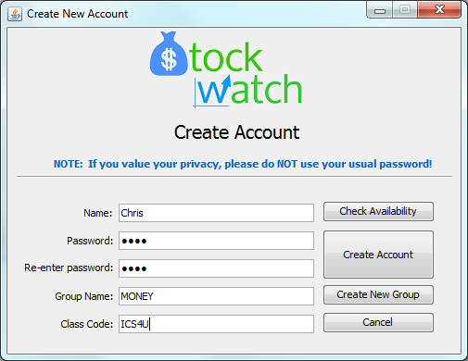You click ‘Create Account’ and then confirm the creation of the account before attempting to log in

Logging In

After creating an account you should be able to enter your name and password to access your group’s watch list. If you’ve forgotten your username or password, ask your teacher to help you retrieve it (or join your group with a new account)

Using the Watch List

After logging in, you will be presented with table listing all of the stocks that people in your group have purchased as well as the amount of money left to spend (remaining funds) and the current worth of your group in the bottom left corner.

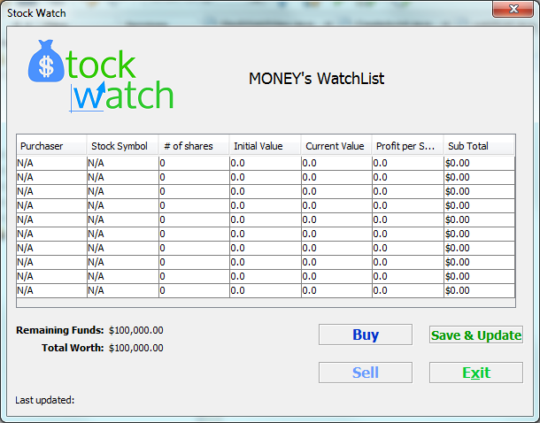

**To buy a stock:** When you know the stock symbol of a stock you’re interested in buying for your group, click ‘Buy’ to add that stock to the watch list. Clicking ‘Save & Update’ will save your stack so that when others in your group click the same button they can see what you’ve just bought.

**To sell a stock**, simply click ‘Sell’ and enter the number of shares you wish to sell. When asked how many stocks you’d like to sell, enter -1 to remove the stock from your watch list – selling all of the stocks you have leaves you with zero of that stock, but it will still appear in your watch list.

**‘Save & Update’** will fetch any stocks that other members in your group have recently bought and check (and if necessary, update) the values of the stocks. This is limited to once every 3 seconds to prevent spamming.

**‘Exit’** will close the program

**NOTE:** If possible, try to avoid buying and selling at the same time as another group member – there is a chance that your purchase will be overwritten! This is also the reason for the restriction on how often you can buy and update the watch list.

Errors

The most common error you will run into will be the overwriting of stocks when two members buy stocks at the same time as each other. However, if you receive error #9001 or #-1337, contact support ([stanleyhu002@gmail.com](mailto:stanleyhu002@gmail.com)), as you likely have an error related to the way the program fetches stock prices and the program will need to be updated. Errors might also be caused by corrupted files or files being accessed at the same time in which case manual editing (see admin manual) and restarting the program respectively should fix the problem.